
UNIVERSITY OF WAH
DEPARTMENT OF COMPUTER SCIENCE
BSCS 3RD B
SUBMITTED TO: SIR. HASSAN SHAFAQAT
SUBMITTED BY: SAADI SAFDAR
REG #: UW-24-CS-BS-088
COURSE TITLE: COMPUTER NETWORKS
COURSE CODE: CS – 241 L
LAB REPORT # 1
CISCO PACKET TRACER
- Cisco Packet Tracer is Launched.
- 1 switch is added
- 2 hubs are added
- 4 PCs and 4 Laptops are added
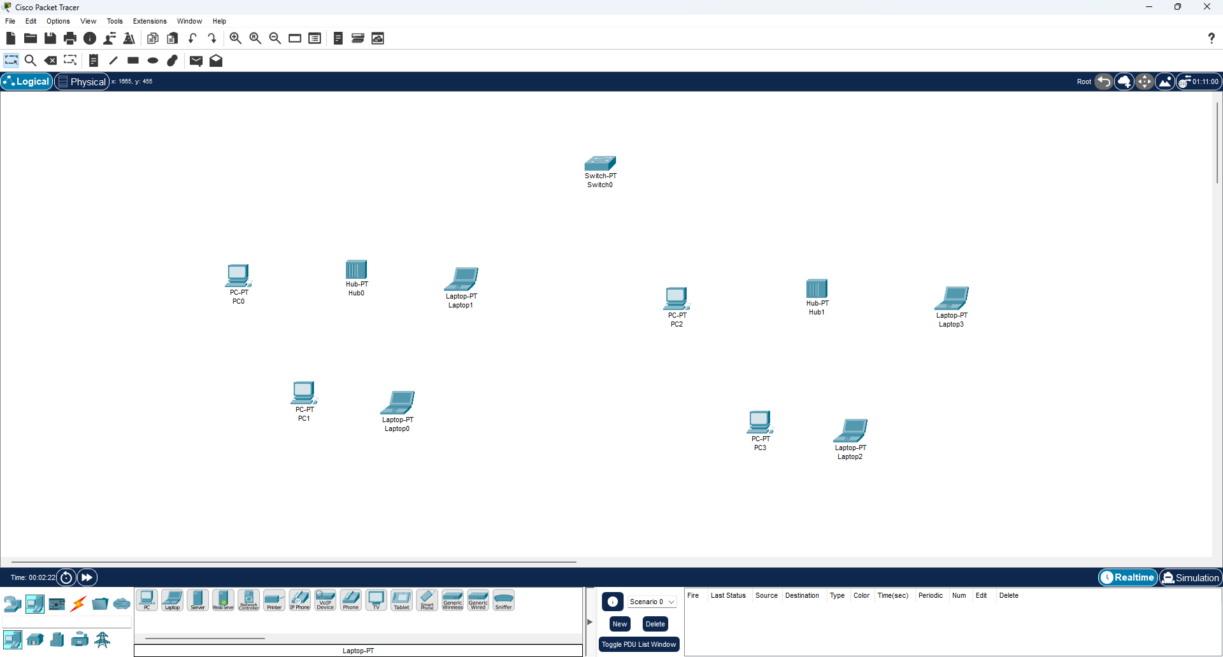
- Every End Device(PCs & Laptops) is connected to Network Device(Hub) by Connection: Copper Straight-Through by FastEthernet
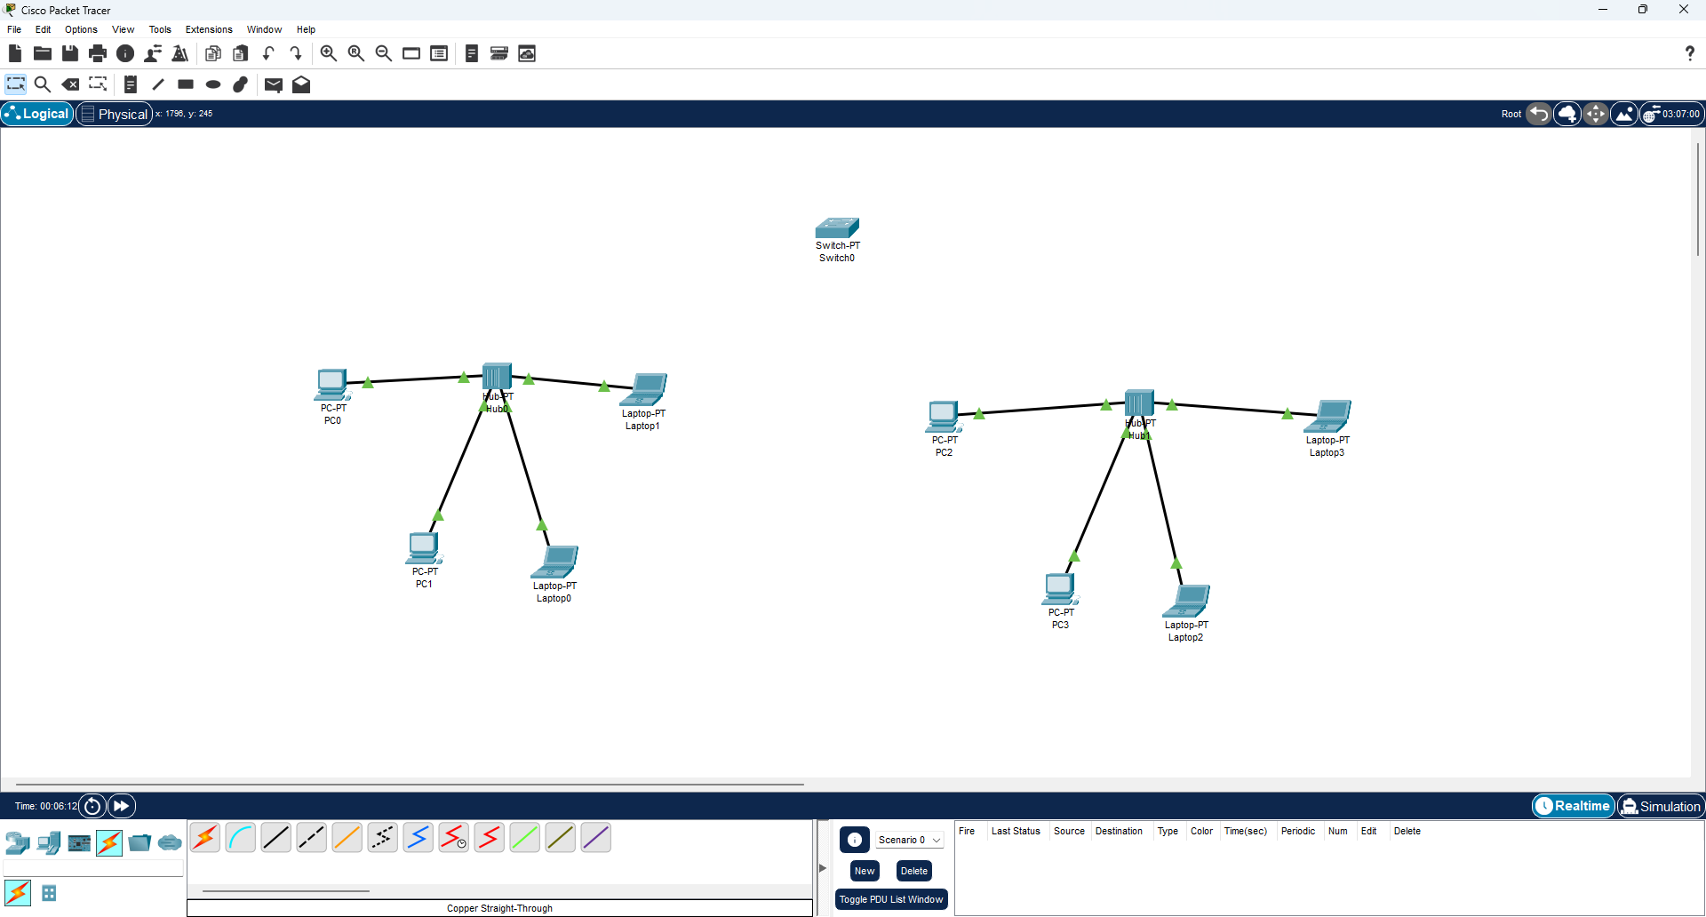
- Every End Device(Hubs) is connected to Network Device(Switch) by Connection: Automatically Choose Connection Type

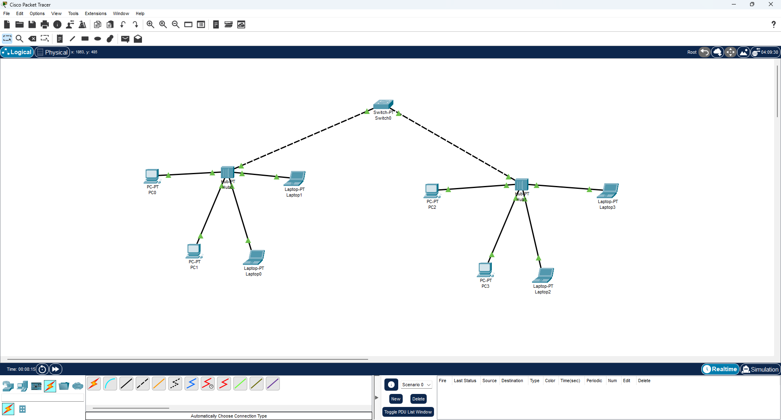

- IP Configuration for End Devices are going to be setted
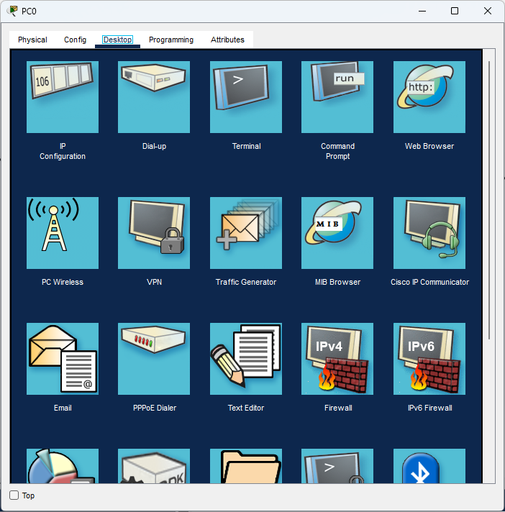

- For PC 0, IP Address is 192.168.1.88

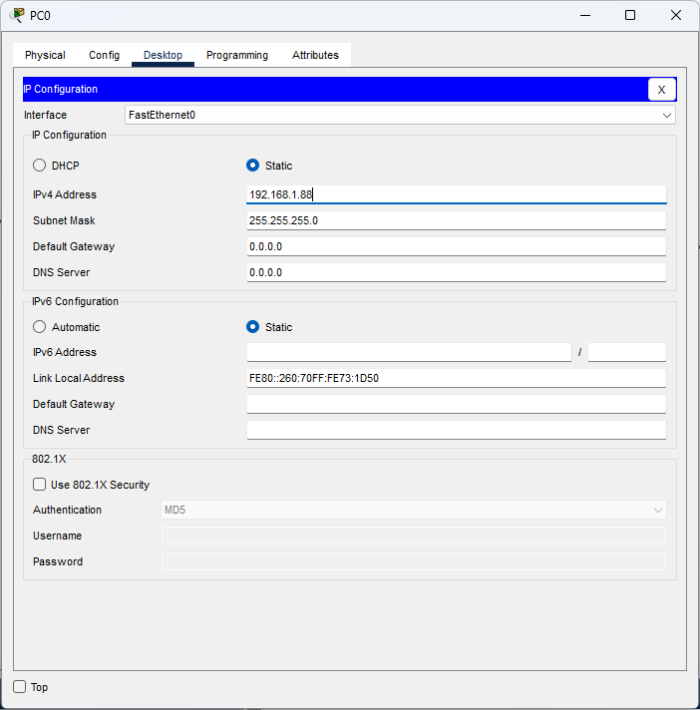

- For PC 1, IP Address is 192.168.1.89

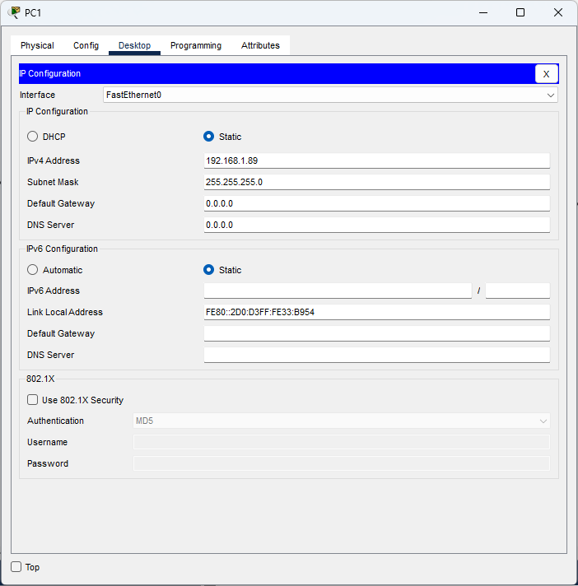

- For Laptop 0, IP Address is 192.168.1.90

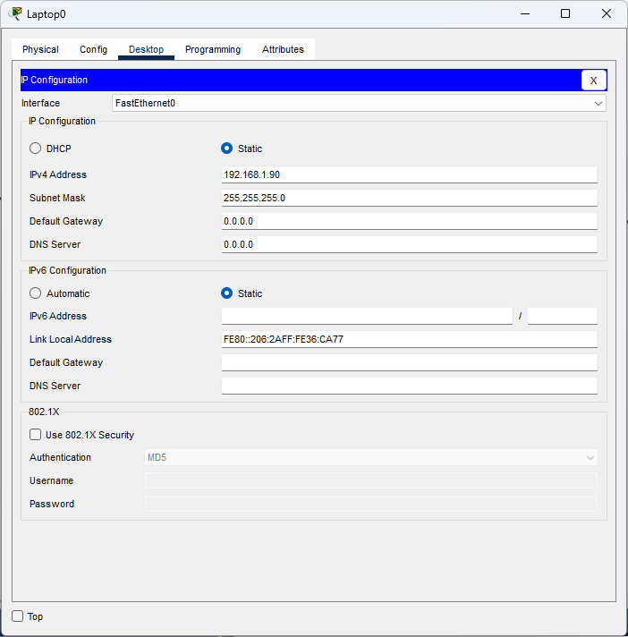

- For Laptop 1, IP Address is 192.168.1.91

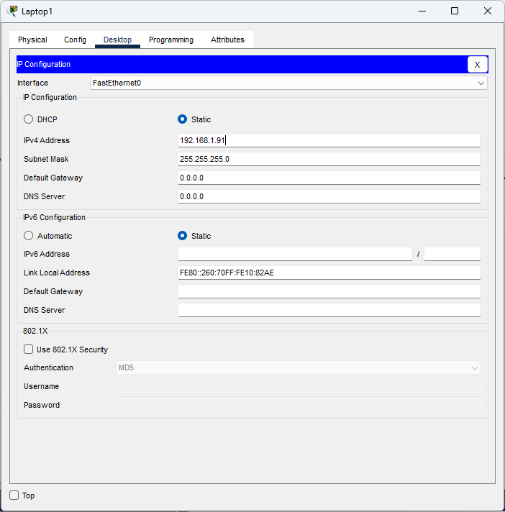

- For PC 2, IP Address is 192.168.1.92

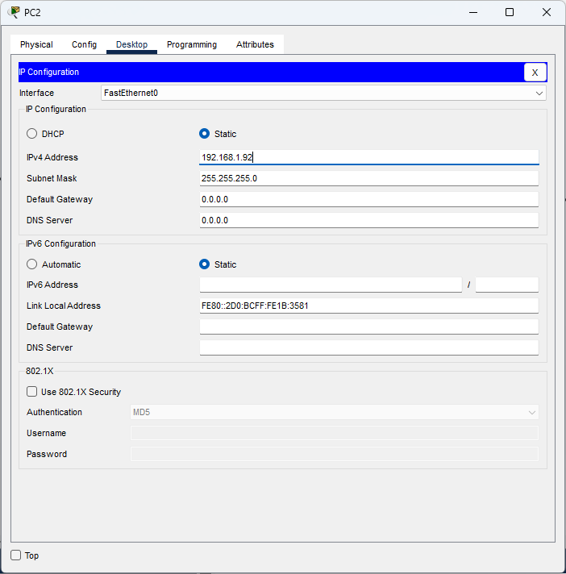

- For PC 3, IP Address is 192.168.1.93

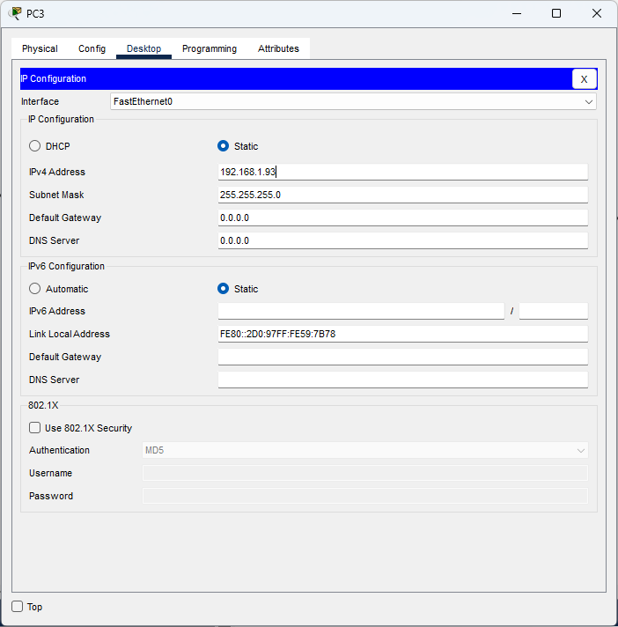

- For Laptop 2, IP Address is 192.168.1.94

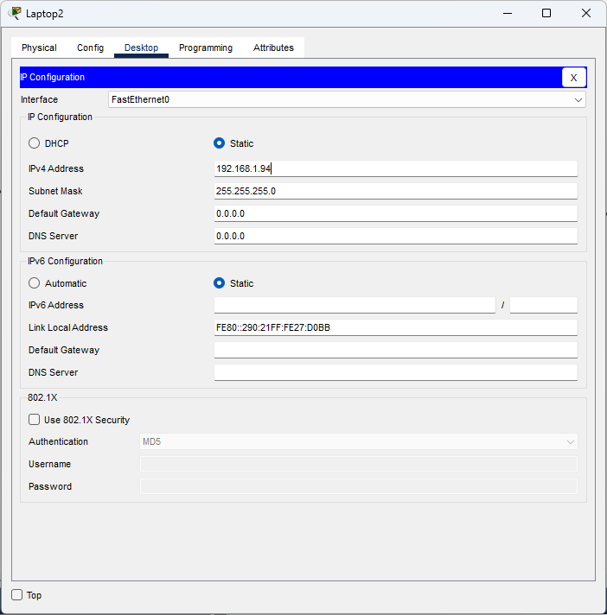

- For Laptop 3, IP Address is 192.168.1.95

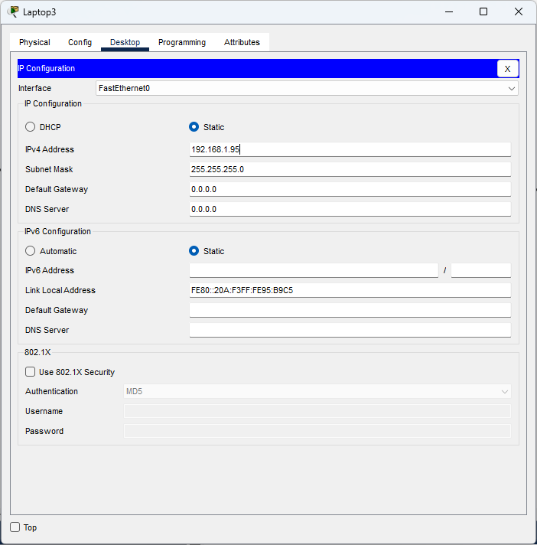

- Here are all the successful connections between End Devices:
- PC 0 is successfully connected to PC 0, PC 1, Laptop 0, Laptop 1, PC 2, PC 3, Laptop 2, Laptop 3
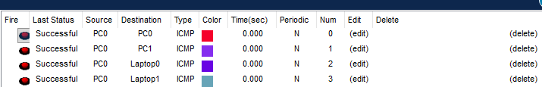
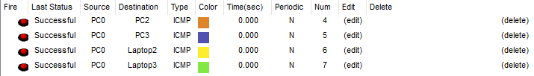
- PC 1 is successfully connected to PC 0, PC 1, Laptop 0, Laptop 1, PC 2, PC 3, Laptop 2, Laptop 3
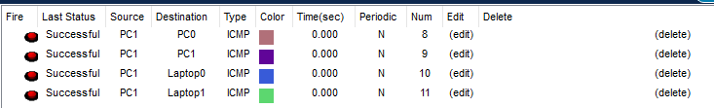
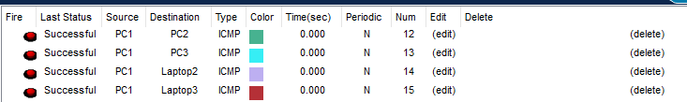
- Laptop 0 is successfully connected to PC 0, PC 1, Laptop 0, Laptop 1, PC 2, PC 3, Laptop 2, Laptop 3
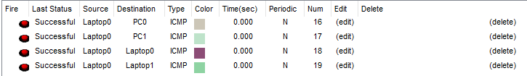
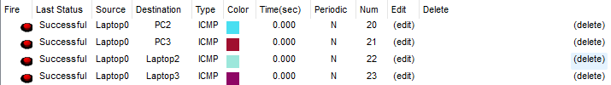
- Laptop 1 is successfully connected to PC 0, PC 1, Laptop 0, Laptop 1, PC 2, PC 3, Laptop 2, Laptop 3
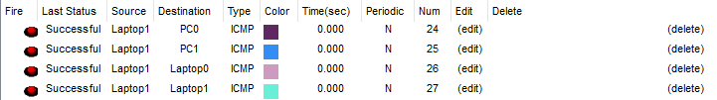
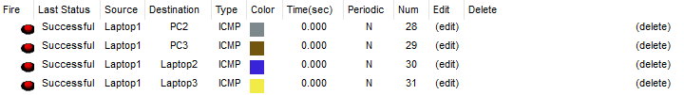
- PC 2 is successfully connected to PC 0, PC 1, Laptop 0, Laptop 1, PC 2, PC 3, Laptop 2, Laptop 3
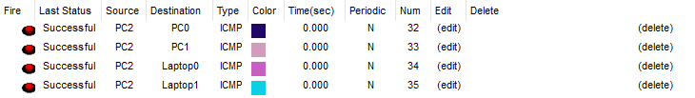
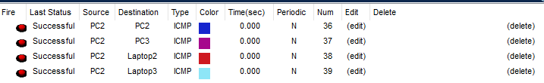
- PC 3 is successfully connected to PC 0, PC 1, Laptop 0, Laptop 1, PC 2, PC 3, Laptop 2, Laptop 3
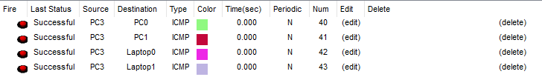
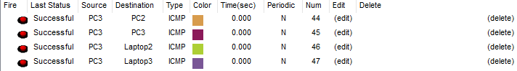
- Laptop 2 is successfully connected to PC 0, PC 1, Laptop 0, Laptop 1, PC 2, PC 3, Laptop 2, Laptop 3
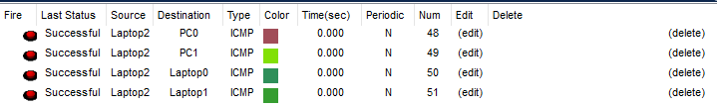
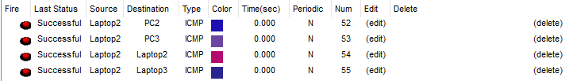
- Laptop 3 is successfully connected to PC 0, PC 1, Laptop 0, Laptop 1, PC 2, PC 3, Laptop 2, Laptop 3
